Dr. Reevesinator GoogleHappy Status Report

4/13/20

**TESTS**

nameEqualityAfterSort1: asserts name in team after sorting is Eden

nameEqualityAfterSort2: Asserts name in team after sorting in position 4 is Nic

pageRankEquality1: Asserts the pagerank of positions 0 through 2 after sorting

pageRankEquality2: Asserts the pagerank of positions 3 through 5 after sorting

pageRankEquality3: Asserts the pagerank of positions 6 through 8 after sorting

zdtest36: Testing verbosity

zetest37: Testing verbosity

zftest38: Testing verbosity

zgtest39: Testing verbosity for team size

zhtest40: Testing verbosity for proposal option, team size, and other alternative options

**RELEASE WALL**

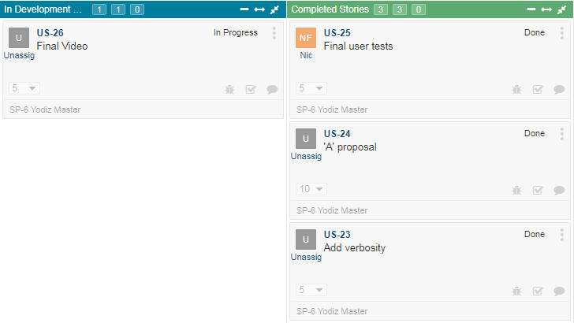

**STORYBOARD**

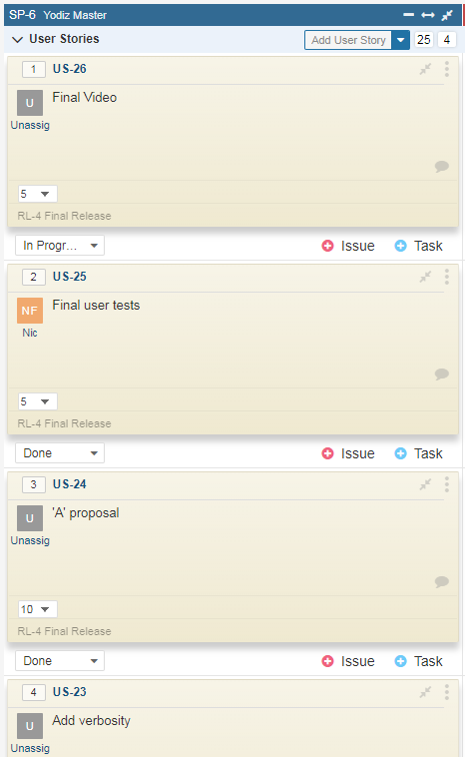

**CONTRIBUTION**

Ben: 40%

Nic: 45%

Wade: 15%

**UPDATED THINGS**

Added in verbose way for user to choose whether person with most or least amount of references has preferential treatment.